Basic Ubuntu Commands for Beginner:

1. sudo
sudo (SuperUser DO) Linux command allows you to run programs or other commands with administrative privileges, just like “Run as administrator” in Windows. This is useful when, for example, you need to modify files in a directory that your user wouldn’t normally have access to.

2. apt-get
apt-get is the one of the most important Ubuntu commands every beginner must know. It is used to install, update, upgrade and remove any package. apt-get basically works on a database of available packages. Here is the list of different apt-get commands:

1. sudo apt-get update
apt-get update with super user privileges is the first command you need to run in any Linux system after a fresh install. This command updates the database and let your system know if there are newer packages available or not.
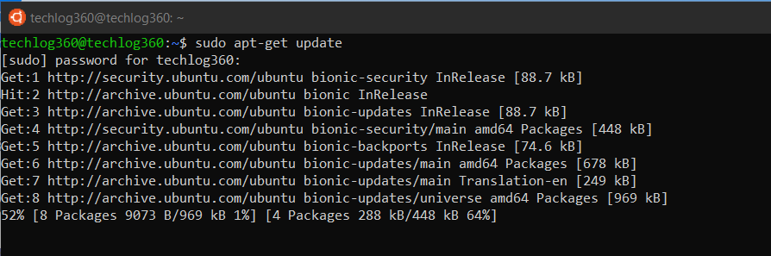

2. sudo apt-get upgrade
After updating the package database, next step is to to upgrade the installed packages. For upgrading all the packages with available updates you can use this command.
And if you like to upgrade a particular package, you should tweak the above command a little:
sudo apt-get upgrade <package-name>
Replace the <package-name> with your desired package.

3. sudo apt-get install
If you know the name of the package, then you can easily install a program using this command:
sudo apt-get install <package-name>
Replace the <package-name> with your desired package.

If you are not sure about the package name, you can type a few letters and press tab and it will suggest all the packages available with those letters. Thanks for auto-completion feature.

4. sudo apt-get remove
When it comes to removing the installed program apt-get remove command suits your need. You only have to know the exact package name of the software you want to uninstall.
If you don’t know the package name, use below ubuntu basic command to list all the packages installed on your system and then copy the package name from the list:
dpkg --list
Now run the apt-get remove command as sudo in order to remove the software:
sudo apt-get remove <package-name>
Replace the <package-name> with the one you copied from the dpkg list.
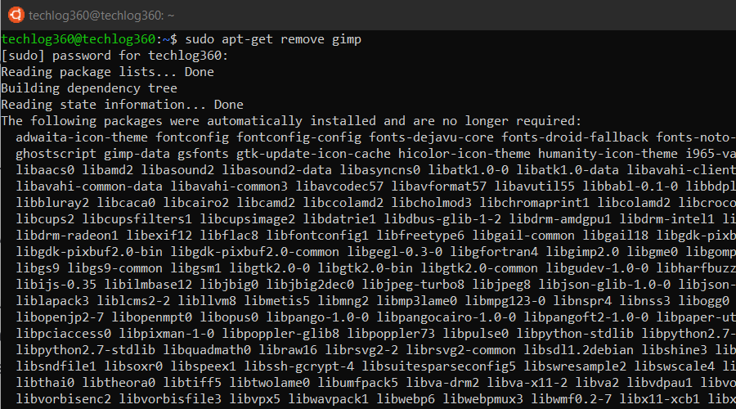

apt-get remove command only removes the software from your system but not the configuration or data files of the package. These files help in keeping the same settings when you want to reinstall the same software.

5. sudo apt-get purge
apt-get purge command is used when you want to remove a software completely from your system with its configuration or data files so that no longer personalized settings will be available during reinstallation.
Run the apt-get purge command as sudo in order to remove the software completely:
sudo apt-get purge <package-name>
Replace the <package-name> with the application that you want to remove or copied from the dpkg list.
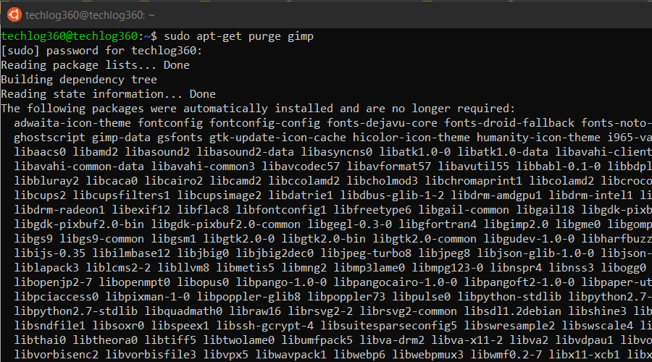

6. sudo apt-get autoremove
apt-get autoremove command is used to remove any unnecessary packages. Unnecessary means, whenever you install an application, the system will also install the software that this application depends on. It is common in Ubuntu that applications share the same libraries. When you remove the application the dependency will stay on your system.
So run apt-get autoremove as sudo after uninstalling a package to remove unwanted software dependencies.
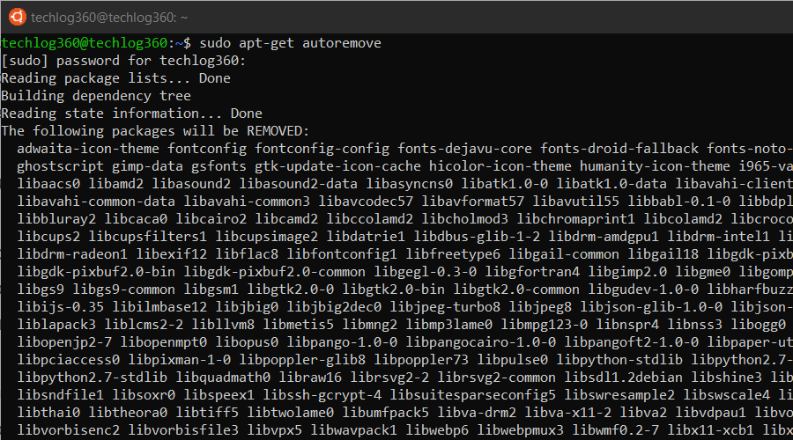
So apt-get autoremove will remove those dependencies that were installed with applications and that are no longer used by anything else on the system.

3. ls
ls (list) command lists all files and folders in your current working directory. You can also specify paths to other directories if you want to view their contents.

4. cd
cd (change director”) Linux command also known as chdir used to change the current working directory. It’s one of the most used basic Ubuntu commands. Using this command is easy, just type cd followed by the the folder name. You can use full paths to folders or simply the name of a folder within the directory you are currently working. Some common uses are:
- cd / – Takes you to the root directory.
- cd .. – Takes you up one directory level.
- cd – – Takes you to the previous directory.
Here are some examples to how to use cd command in Ubuntu:
Example 1: cd home – open home folder in current directory.
Example 2: cd Linux\ Drive – open Linux Drive named folder in directory. Here you can see I use backslash because the folder name has spaces so for each space you use “backslash+space”. Like, if your folder name is “am a programmer” then the cd command will be, “cd am\ a\ programmer”.
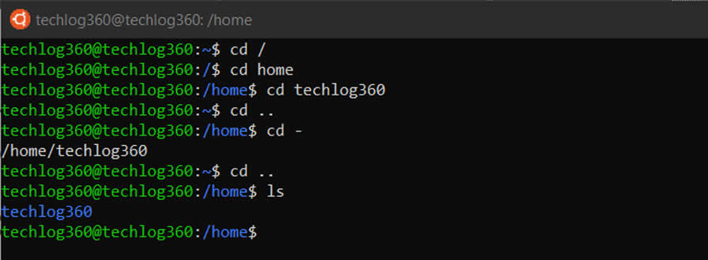

5. pwd
pwd (print working directory) Ubuntu command displays the full pathname of the current working directory.

6. cp
cp (copy) Linux command allows you to copy a file. You should specify both the file you want to be copied and the location you want it copied to – for example, cp xyz /home/myfiles would copy the file “xyz” to the directory “/home/myfiles”.

7. mv
mv (move) command allows you to move files. You can also rename files by moving them to the directory they are currently in, but under a new name. The usage is the same as cp – for example mv xyz /home/myfiles would move the file “xyz” to the directory “/home/myfiles”.

8. rm
rm (remove) command removes the specified file.
- rmdir (“remove directory”) – Removes an empty directory.
- rm -r (“remove recursively”) – Removes a directory along with its content.

9. mkdir
mkdir (make directory) command allows you to create a new directory. You can specify where you want the directory created – if you do not do so, it will be created in your current working directory.

10. history
history command displays all of your previous commands up to the history limit.
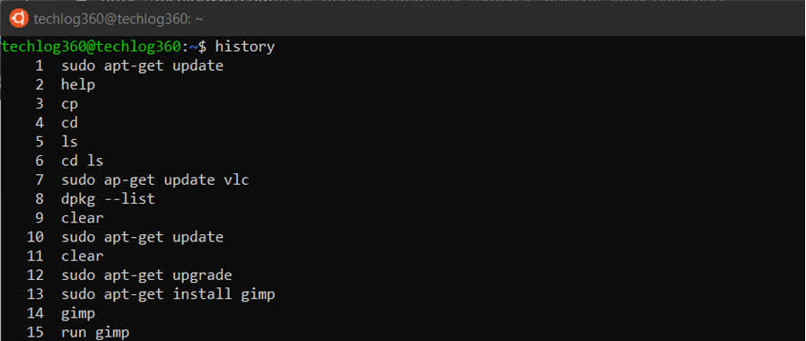

11. df
df (display filesystem) command displays information about the disk space usage of all mounted filesystems.
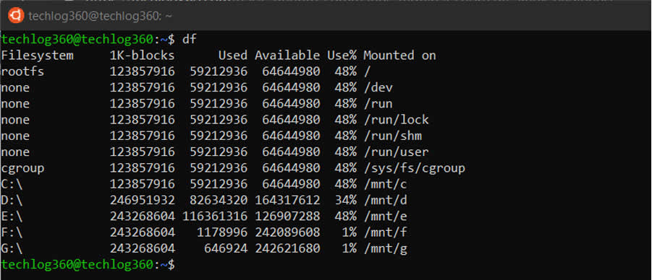

12. du
du (directory usage) command displays the size of a directory and all of its subdirectories.

13. free
free – Displays the amount of free space available on the system.

14. uname -a
uname -a – Provides a wide range of basic information about the system.

15. top
top – Displays the processes using the most system resources at any given time. “q” can be used to exit.

16. man
man command displays a “manual page”. Manual pages are usually very detailed, and it’s recommended that you read the man pages for any command you are unfamiliar with. Some uses are :
- man man – Provides information about the manual itself.
- man intro – Displays a brief introduction to Linux commands.

17. info
Similar to man, but often provides more detailed or precise information.

18. <command name> -h or <command name> –help
This command is a third alternative to get help. While not as detailed as the info or man pages, this will provide a quick overview of the command and its uses.
For example: man -h or man -help

19. passwd
passwd Ubuntu basic command is used to change user password using Terminal. What you have to do is run the below command, where is the username whose password has to change:
passwd <user>

20. whatis
whatis command shows a brief description of what is the functionality of specific built-in Linux command.
whatis <command>
Some examples are:
- whatis cd
- whatis man
- whatis help
Above commands will display the purpose of cd, man and help commands.

Ubuntu Terminal Shortcuts:
To further ease up your skill, these Ubuntu Terminal keyboard shortcuts would help.
Ubuntu Terminal Shortcuts | Function
Ctrl + Shift + T | Open new tab on current terminal
Ctrl + Shift + W | Close the current tab
Ctrl + A | Move cursor to beginning of line
Ctrl + E | Move cursor to end of line
Ctrl + U | Clears the entire current line
Ctrl + K | Clears the command from the cursor right
Ctrl + W | Delete the word before the cursor
Ctrl + R | Allows you to search your history for commands matching what you have typed
Ctrl + C | Kill the current process
Ctrl + Z | Suspend the current process by sending the signal SIGSTOP
Ctrl + L | Clears the terminal output
Alt + F | Move forward one word
Alt + B | Move backward one word
Ctrl + Shift + C | Copy the highlighted command to the clipboard
Ctrl + Shift + V or Shift + Insert | Paste the contents of the clipboard
Up/Down Arrow keys | To scroll through your command history, allowing you to quickly execute the same command multiple times
TAB | Used to complete the command you are typing. If more than one command is possible, you can press it multiple times to scroll through the possible completions. If a very wide number of commands are possible, it can output a list of all possible completions.

Git & GitHub

Git is version-control software. It was created by Linus Torvalds, the guy who invented Linux.
You don’t have to be running Linux to use git–you can use it on Windows and Mac, too
Git lets you easily keep track of every revision you and your team make during the development
of your software. You all share one repository of code that is worked on independently and then
merged back together. You also do not need to be connected all the time because the project is
both saved locally on each machine and remotely (probably at Github).
Required Vocabulary
When you’re first starting to use git, it can be intimidating. Commands and concepts may seem
totally foreign if you’ve never used any form of version control in the past. You will pick them up
super fast.
Repository:
Often referred to as a repo. A repository is the collection of files and folders that you’re using git
to track. The repository consists of the entire history of your team’s changes to the project. It’s
the big ole box you and your team throw your code into.
Github:
The most popular remote storage solution for git repos. It also allows you to set access
permissions for projects, track and submit bugs, accept feature requests, subscribe to repository
notifications, and utilize a graphic interface, rather than use the command line. Repos default to
public, but paid accounts can have private ones.
Clone:
Cloning a repo is pretty much exactly what it sounds like. It takes the entire online repository
and makes an exact copy of it on your local machine. You will need to do this for any number of
reasons, not the least of which are starting in the middle of a project with a new team, swapping
workstations, or starting over from a corrupted repo.
Commit:
Think of this as saving your work. When you commit to a repository, it’s like you’re gathering up
the files as they exist at that moment and putting them in a time capsule. The commit will only
exist on your local machine until it is pushed to a remote repository.
Push:
Pushing is the bread to committing’s butter. Committing throws your files into the timecapsule,
and pushing is what launches the capsule into space. Pushing is essentially syncing your
commits to the cloud (again, probably Github). You can push multiple commits at once, too. You
can work offline, commit lots of work, and then push it all up to Github when you’re back in
civilization with that sweet, sweet wifi.

https://www.youtube.com/watch?v=ZMgLZUYd8Cw&t=430s

